Lab - ANP-C9531 - The structure of java programs

Assignment-1.

● Create a class Student in Student.java then add member variables studentName, collegeName of type String

● Add a member variable studentID of type int.

● Make all the member variables as private.

● Add a main method. And print a message “Successful”.

● Compile the class

● Run the class (Follow Coding convention)

**CODE :**

**package** assigment1;

**public** **class** Student {

// Private member variables

**private** String studentName;

**private** String collegeName;

**private** **int** studentID;

// constructor to initialize

**public** Student(String studentName, String collegeName, **int** studentID) {

**this**.studentName = studentName;

**this**.collegeName = collegeName;

**this**.studentID = studentID; }

// Public methods for accessing student information

**public** String getStudentName() {

**return** studentName;

}

**public** String getCollegeName() {

**return** collegeName;

}

**public** **int** getStudentID() {

**return** studentID; }

// Main method for demonstration

**public** **static** **void** main(String[] args) {

// Create a Student object with sample values

Student student1 = **new** Student("Alexa", "Jain University", 12345);

System.***out***.println("Student information:");

System.***out***.println("Name: " + student1.getStudentName());

System.***out***.println("College: " + student1.getCollegeName());

System.***out***.println("ID: " + student1.getStudentID());

// Successful execution message

System.***out***.println("Successful");

}}

Output :

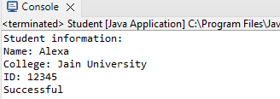

Assignment-2.

● Create a new class Employee

● Add member variables: id and age of type int, name of type String and is Permanent of type boolean

● Now assign values 35.5 to age; See the error message.

● How can you avoid this error? Correct the error by casting.

● Make all the members protected

● Add a main method to it. Print message “Successfully started”.

● Compile the class.

CODE :

**package** assigment1;

//Employee.java

**public** **class** Employee1 {

// Protected member variables

**protected** **int** id;

**protected** **int** age;

**protected** String name;

**protected** **boolean** isPermanent;

// Main method

**public** **static** **void** main(String[] args) {

// Create an instance of Employee

Employee emp = **new** Employee();

// Assigning values to the member variables

emp.id = 101;

emp.name = "Johny";

emp.isPermanent = **true**;

// Correcting the error by casting

emp.*age* = (**int**) 35.5; // Casting double to int, which will store 35

// Print success message

System.***out***.println("Successfully started");

}

}

Output

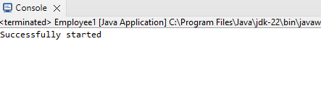

Assignment-3.

● Create a class Person

● Add member variables name as String, age and salary as int

● Initialize the member variable along with declaration.

● Now put the previous Person class in a package com.anudip.learning

● Add a main method. Add a print message “Test Successful”.

● Run the class after compilation.

● Modify the classpaths to see the error messages on the console.

Code :

//package creation

**package** com.anudip.learning;

**class** Person {

String name = "John Doe";

**int** age = 30;

**int** salary = 50000;

**public** **static** **void** main(String[] args) {

System.***out***.println("Test Successful");

}

}

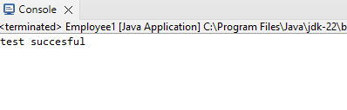

Assignment-4.

● Create a class Rectangle

● Add a member variable width and height of type double.

● Create an enum Color with values RED, GREEN, BLUE

● Create a member variable boxColor of type Color.

● Add a main method.

● In main method just print the enum Color.BLUE (You will notice that Java prints the enum name as it is.)

● Compile and run the class.

Code :

**package** assigment1;

**public** **class** Rectangle {

**double** width;

**double** height;

**enum** Color {

***RED***,

***GREEN***,

***BLUE***

}

Color boxColor;

**public** **static** **void** main(String[] args) {

// Print the enum value

System.***out***.println(Color.***RED***); }}

Output :

